PRACTICAL – 3A

AIM: Installing Raspbian O.S on raspberry Pi.

|  |  |
| --- | --- |
| REQUIREMENTS: | WORKS: |
| Raspberry Pi | The main mini-computer where the OS runs. |
| SD card (Min 16 GB) | Works as the storage drive to hold Raspberry Pi OS and files. |
| HDMI Cable | A cable that transmits high-quality audio and video signals. |
| Monitor | Displays the Raspberry Pi OS interface. |
| USB Cable | Provides power supply to the Raspberry Pi. |
| Adapter (5V, 2.5-3A) | Supplies stable power to the Raspberry Pi. |
| Keyboard & Mouse | Used for input and controlling the Raspberry Pi. |

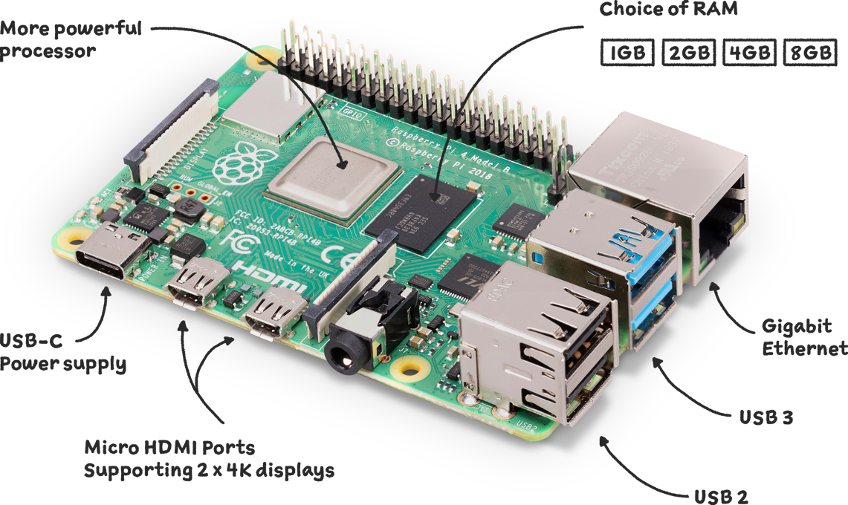**ABOUT RASPBERRY PI**

**CONNECTION**

**Step 1:** Insert the SD card for install the O.S to the raspberry PI.

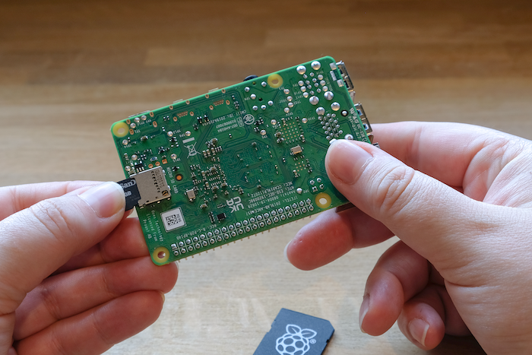

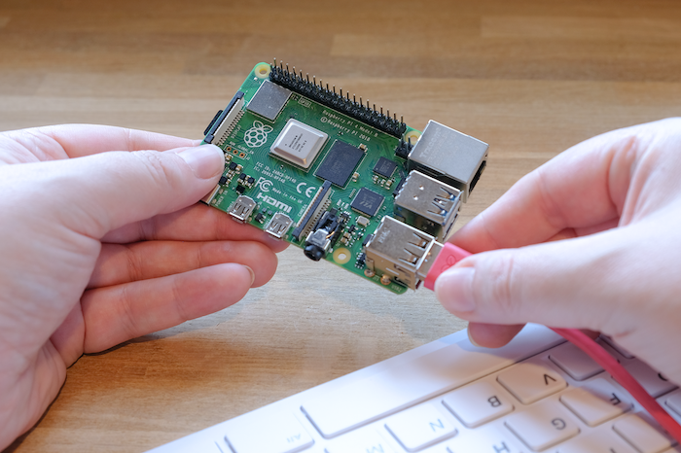**Step 2:** Connect the Keyboard and mouse to Raspberry Pi for user input, navigation, programming, and controlling the operating system easily.

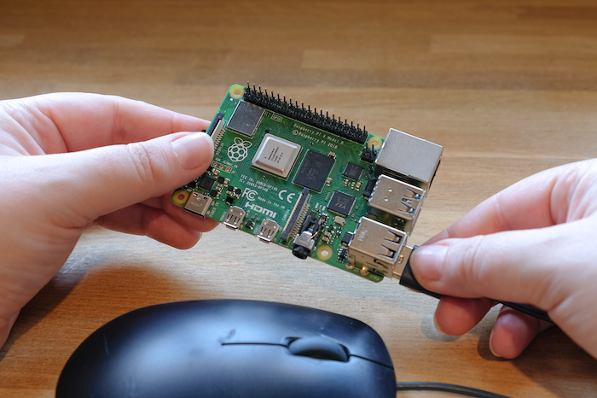

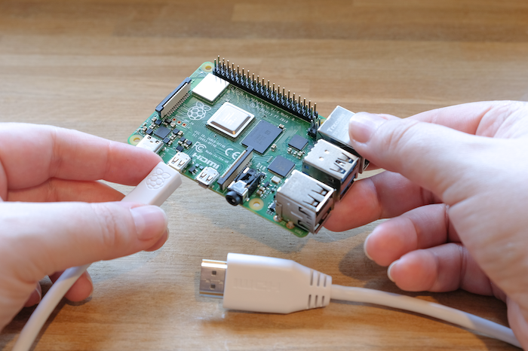**Step 3:** Connect the HDMI cable connects Raspberry Pi to a monitor/TV, enabling display of the operating system, graphics, and user interface.

**Step 4:** Connect the Power cable to supplies the necessary electricity to the Raspberry Pi, allowing it to start, run, and function properly.

When we connect the power supply to the Raspberry Pi, the **LED lights** on the board turn on.

* The **red LED** shows that the power is properly supplied.
* The **green LED** blinks to indicate the SD card is being read and the operating system is loading.

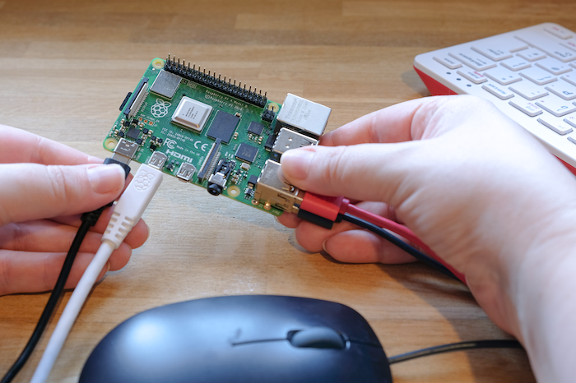

**INSTALLATION**

In the beginning it shows the error of the internet connection like this.

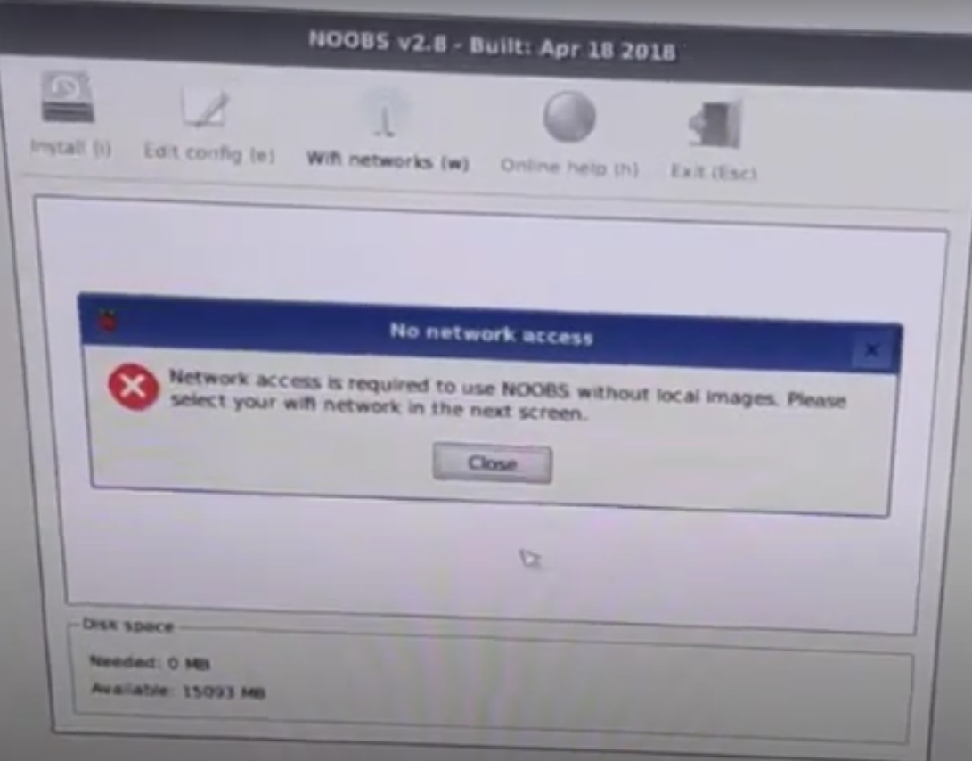

**Step 1:** Select your Wi-Fi name, after the selection of your Wi-Fi name then enter the password and hit the ok button.

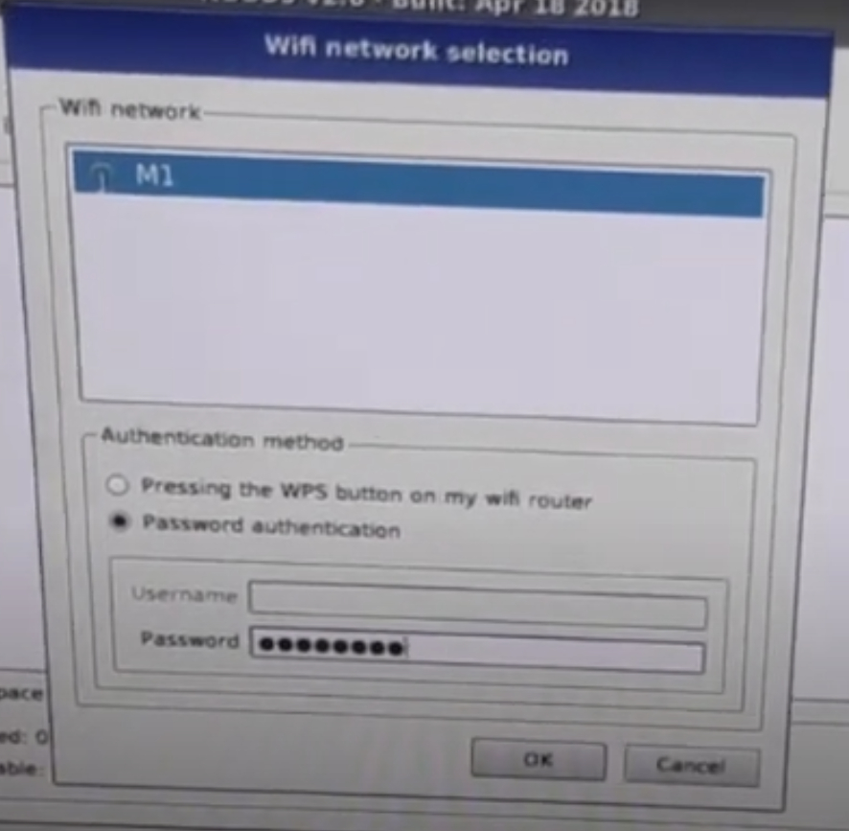

**Step 2:** Select your preferred operating system from the NOOBS menu, then click “Install.” The Raspberry Pi will automatically install it.

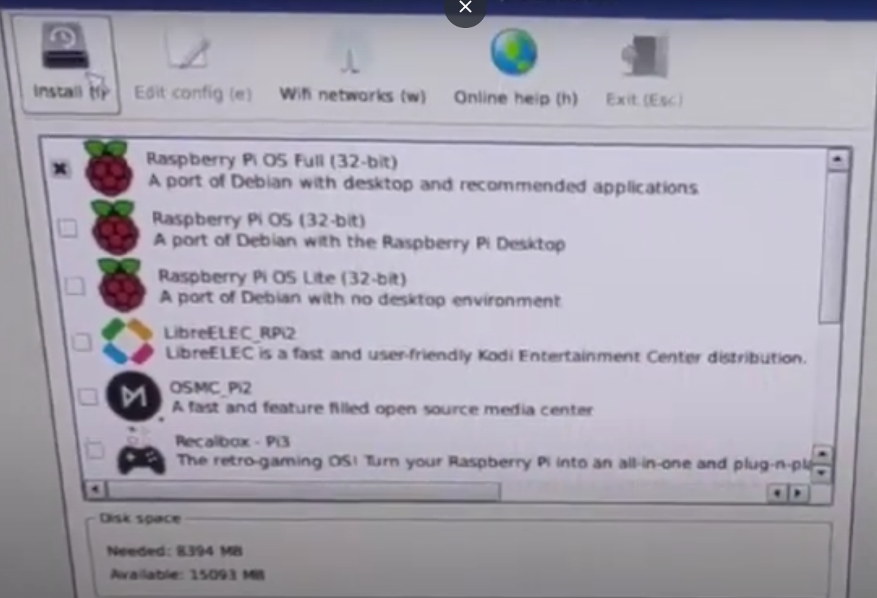

**Step 3:** After clicking on the install button, it shows a warning click on the Yes button.

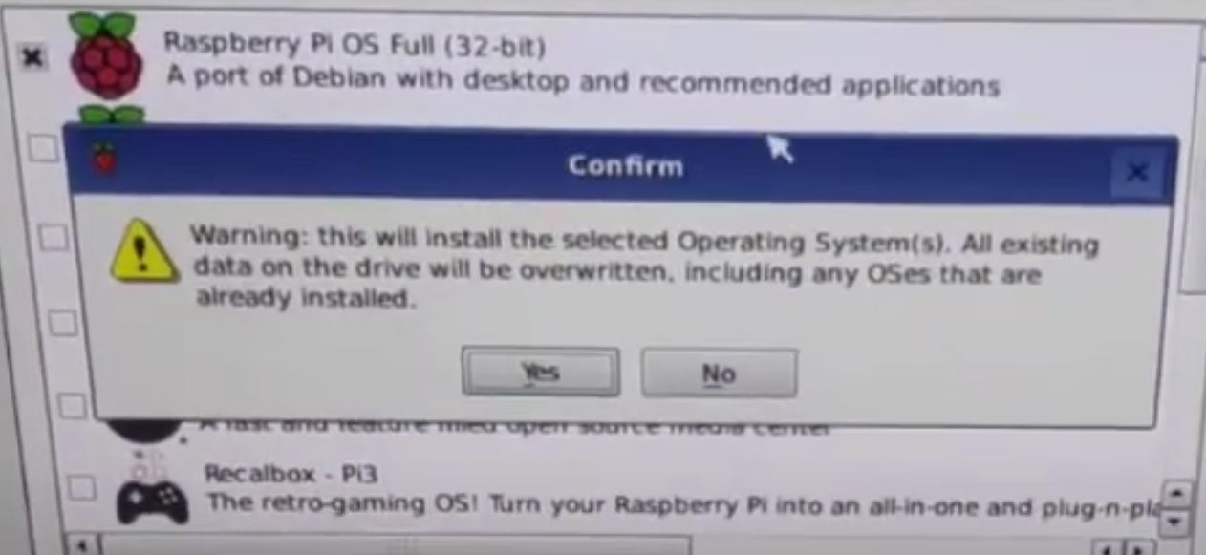

**Step 4:** Now it is Installing.

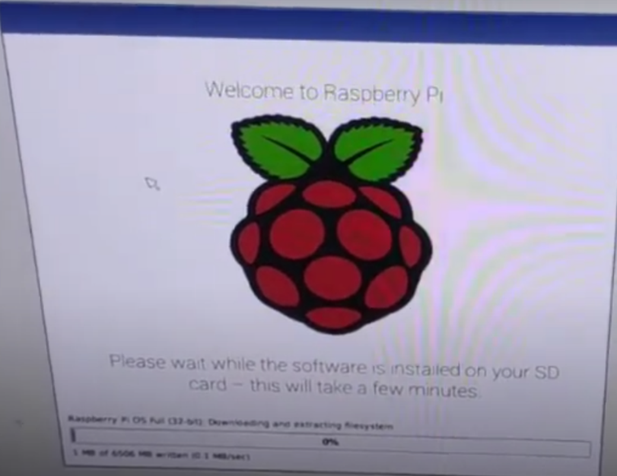

**Step 5:** When this is install then you show the Installed successfully message, then click on OK button.

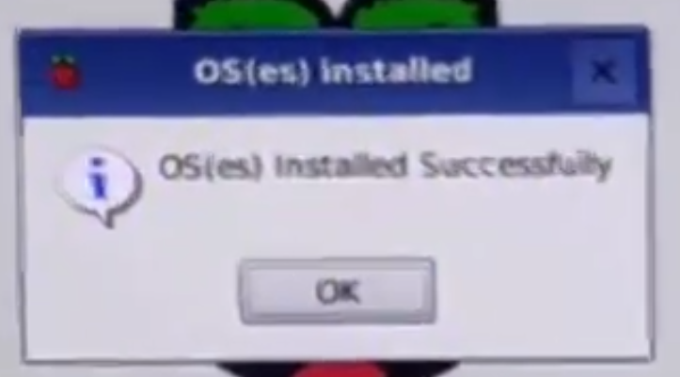

**Step 6:** After the successfully installation then we have to do some set-up, Now you see the set-up dialog click on the Next button.

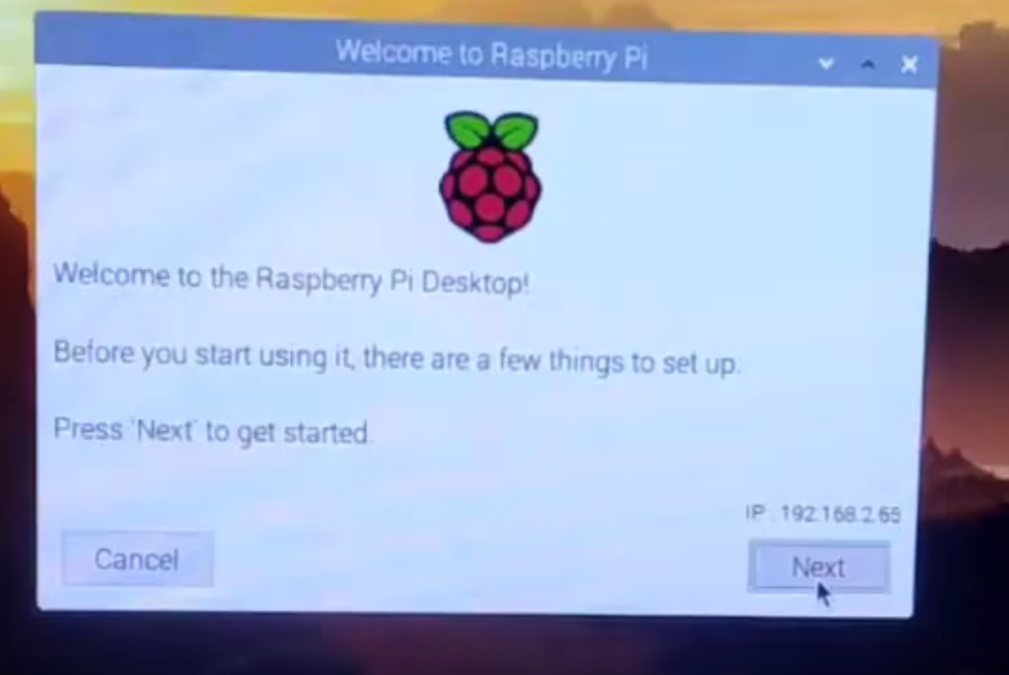

**Step 7:** Then click on the checkbox of Use English Language and Use US Keyboard

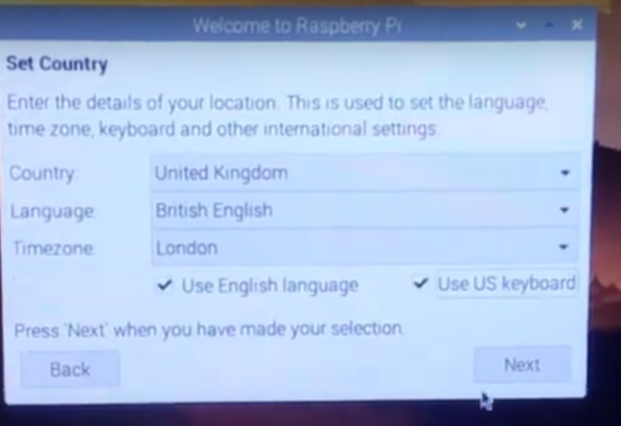

**Step 8:** After clicking the next button then we show the change password interface, here no need to keep password, if you want then you can choose randomly otherwise the default password is “raspberry”. Then click on the next button.

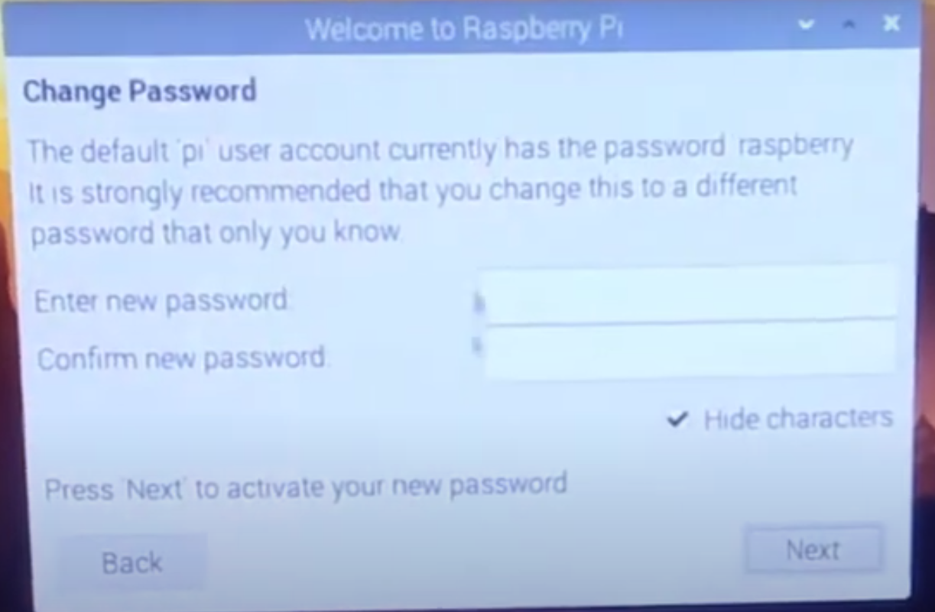

**Step 9:** Now we show the SetUp screen interface, here nothing to do changes then click on the next button.

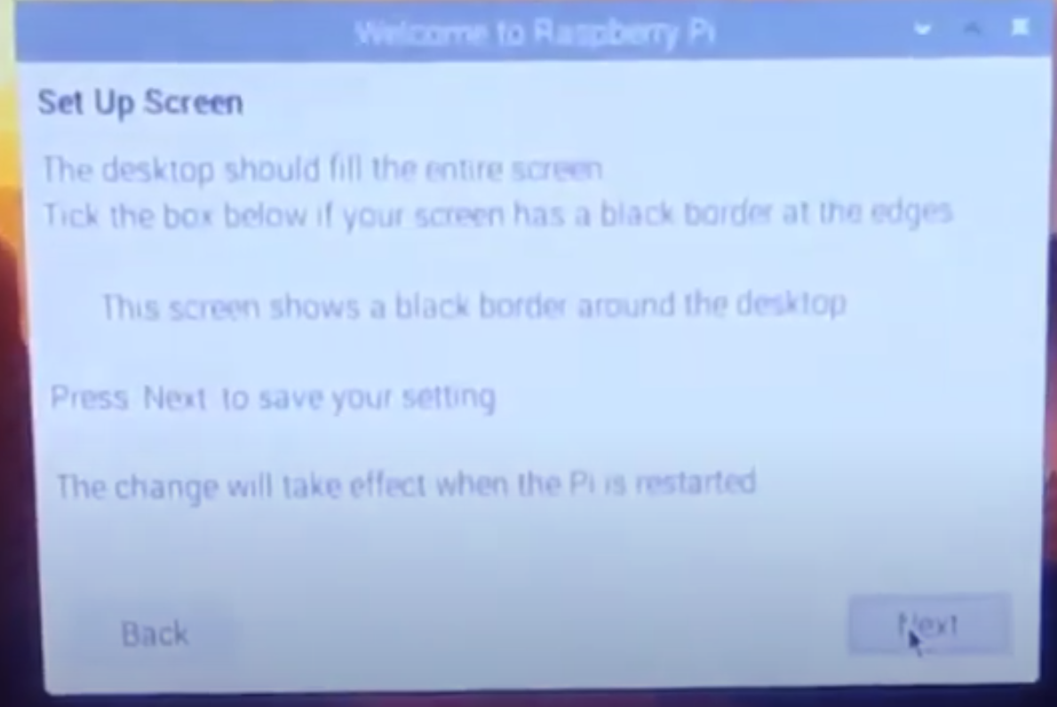

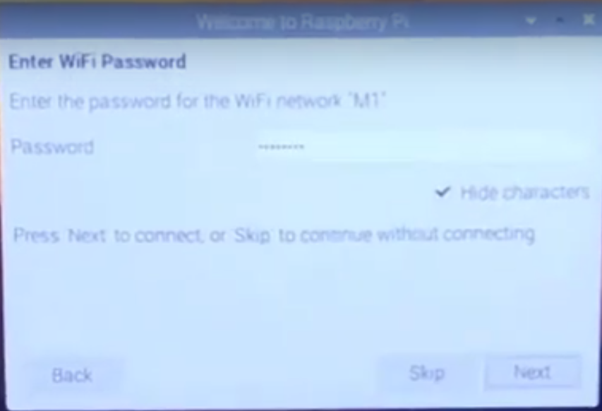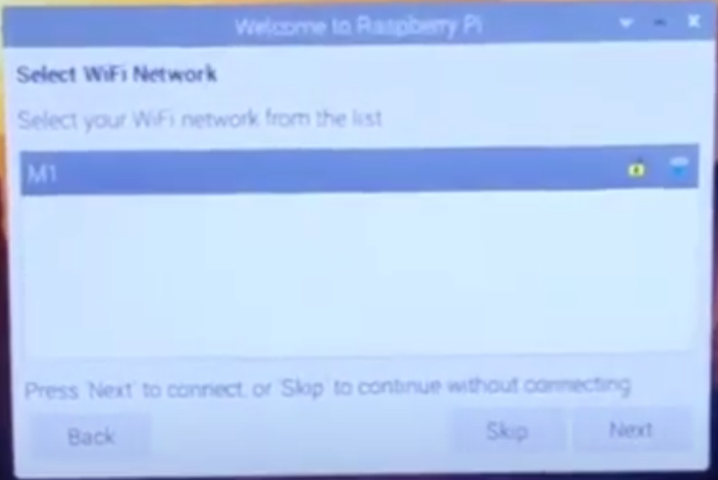**Step 10:** Select your Wi-Fi and select Next button then Enter your Wi-Fi password again click on the Next button.

**Step 11:** Now You see the Update software at this time we don’t need to update it takes so many times to update, so we click here **Skip.**

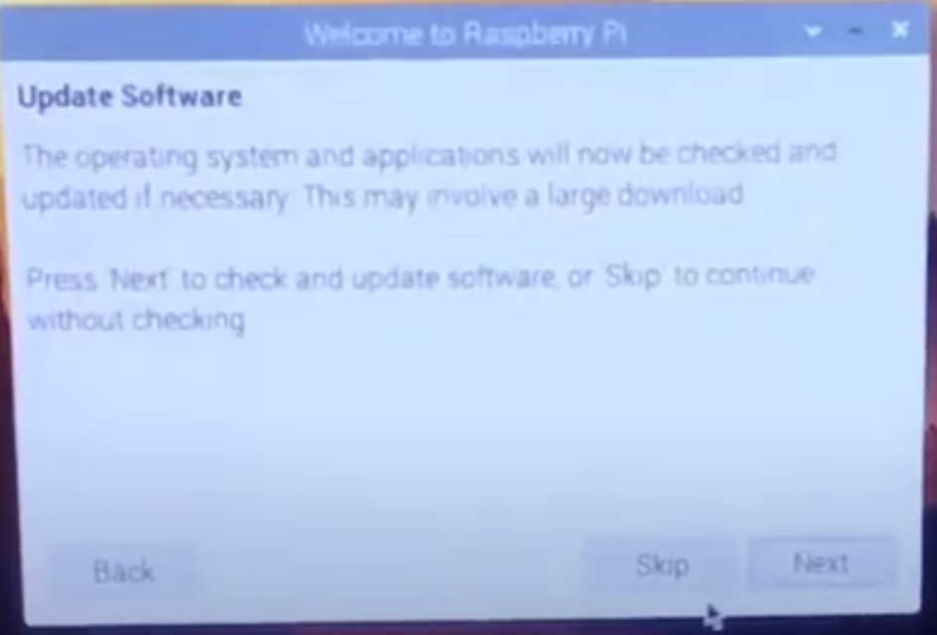

**Step 12:** Now we have the interface of Setup Complete and click on the Done button.

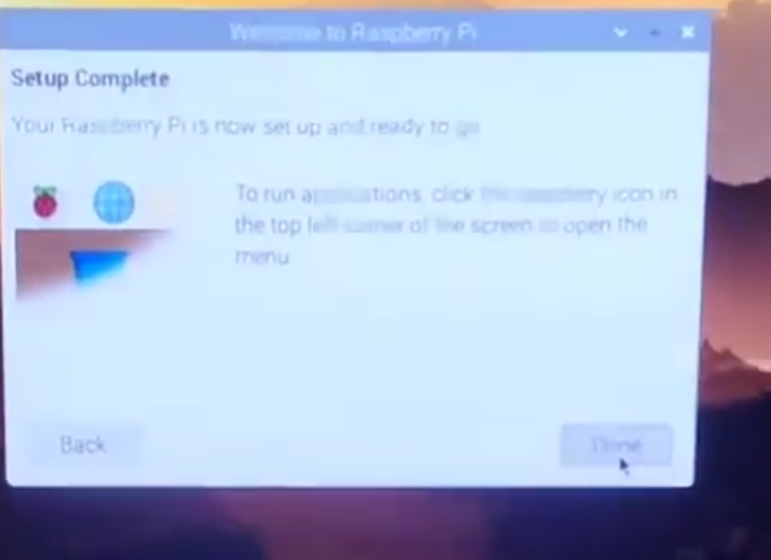

**Step 13:** Now we are good to go to run our raspberry pi. Here is the final Output of the raspberry pi display.

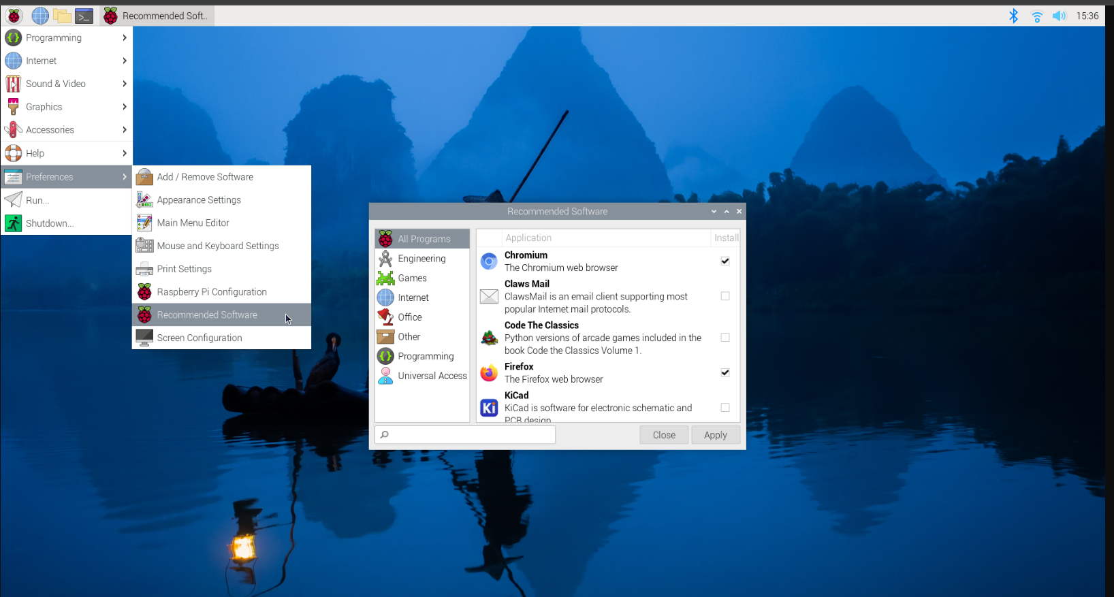

**PRACTICAL – 3B**

**AIM:**  Installing Raspbian OS with the help of virtual Machine software.

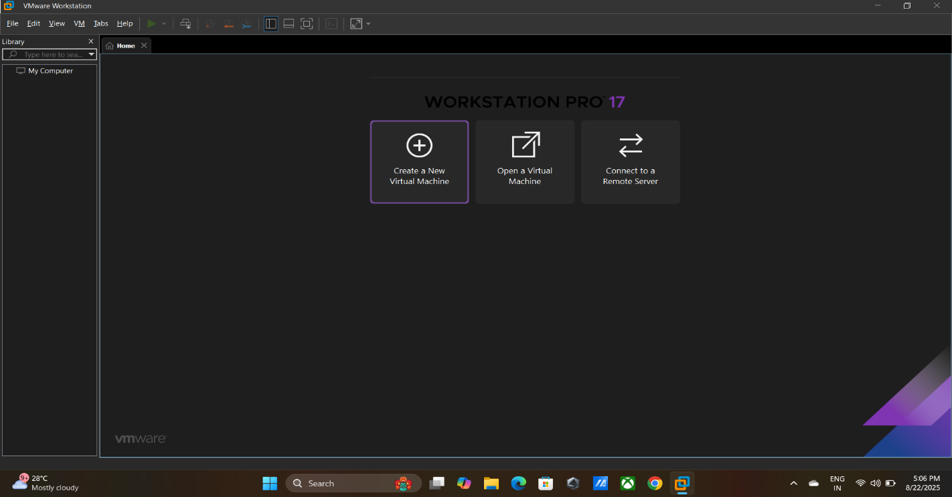**Step 1:** Open VMware and click on create new virtual machine

**Step 2:** Now click on Typical and click on the Next button.

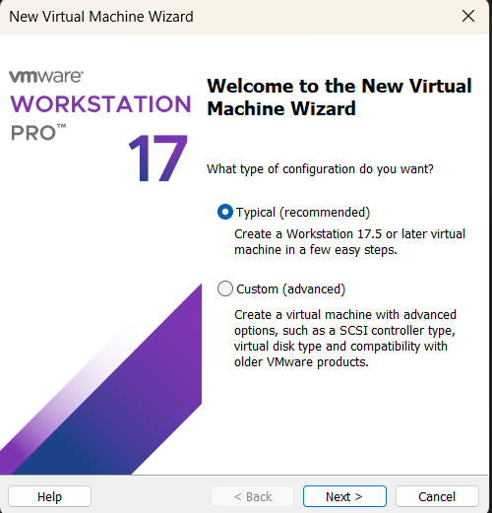

**Step 3:** Then browse the **ISO** file and again hit the next button.

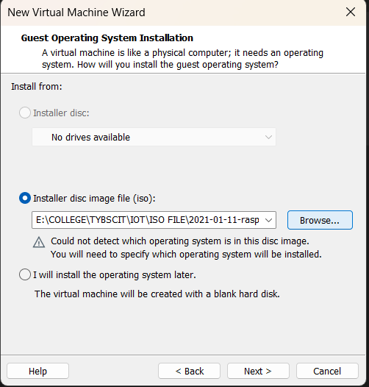

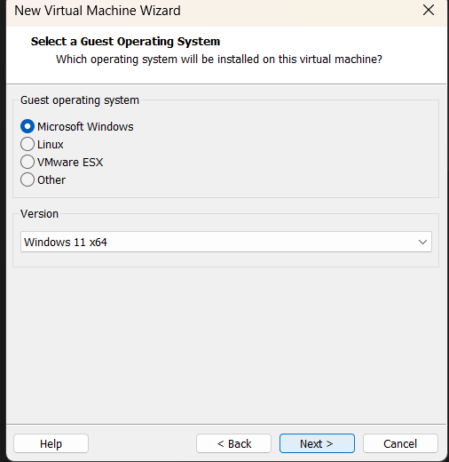**Step 4:** Click on the Microsoft window and click on the Next button.

**Step 5:** Now the system asks the name of our virtual machine, here I don’t want to change the name so I go with the default name then click on the next button.

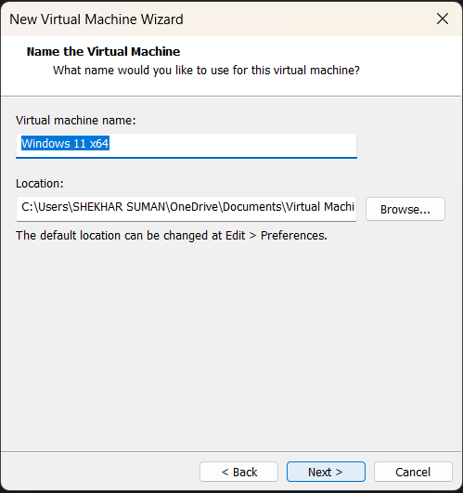

**Step 6:** Then create your strong password then click on the next button.

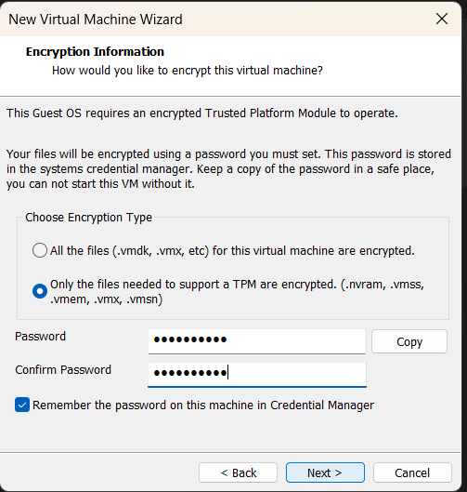

**Step 7**: Nothing to change here and click on the next button.

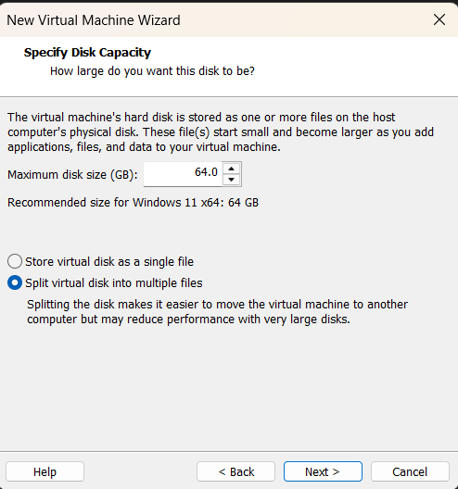

**Step 8:** Then click on the finish button to finish of the setup Raspbian **ISO** file.

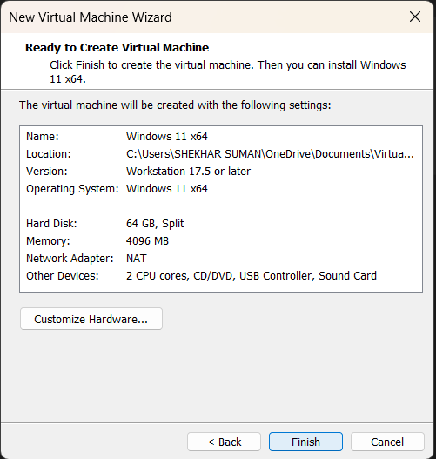

**Step 9:** Now we automatically redirect on the home interface of the VMware application. Select your machine name and click on the power on this virtual machine. This option is at top left hand side.

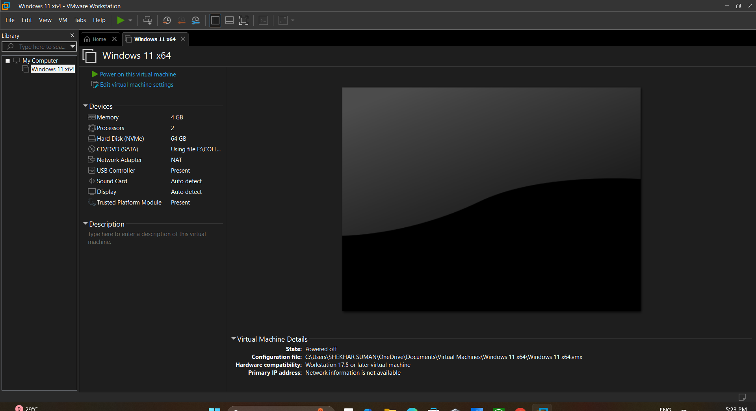

**Step 10:** Now here we show the unwanted option interface click on the OK button for the Next.

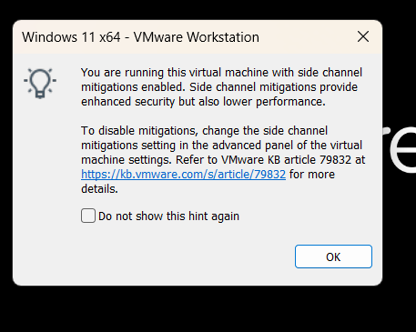

**Step 11:** Now we redirect to the Set-up the Raspbian O.S on the VMware software. Click on the next button.

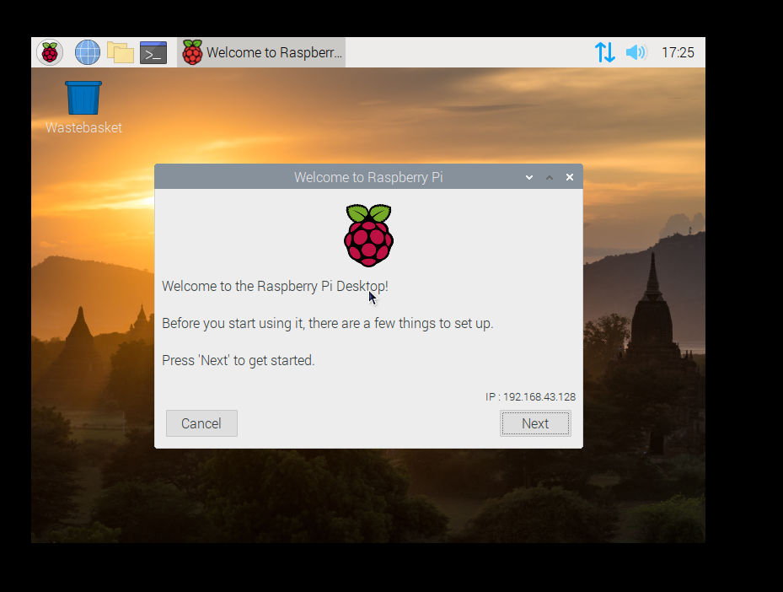

**Step 12:** After clicking on the Next button then click on the both option Use English language and Use U.S keyboard then click on the Next Button.

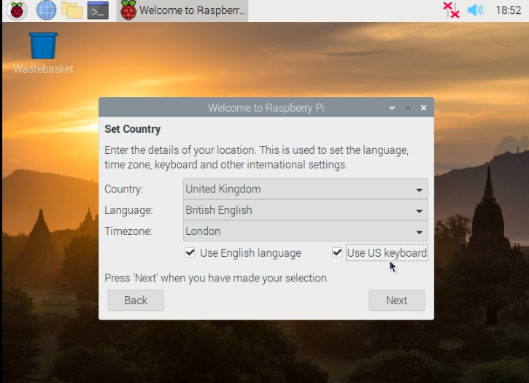

**Step 13:** I don’t want password here so I kept it blanks, if you want your personal password then you can enter the password otherwise, they have their own default password “raspberry”. Then click on the Next button.

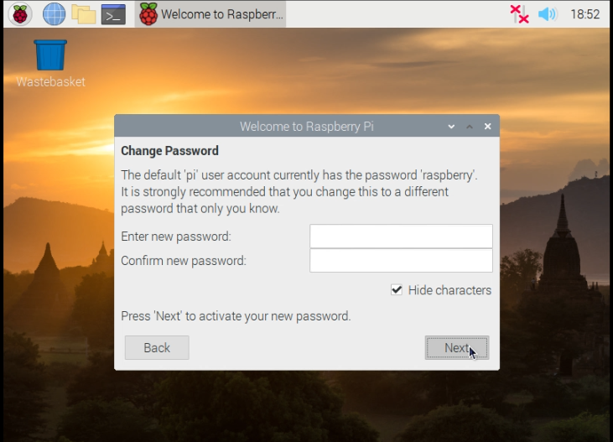

**Step 14:** I don’t want any update right now then I want to choose skip button for the skip the Updates.

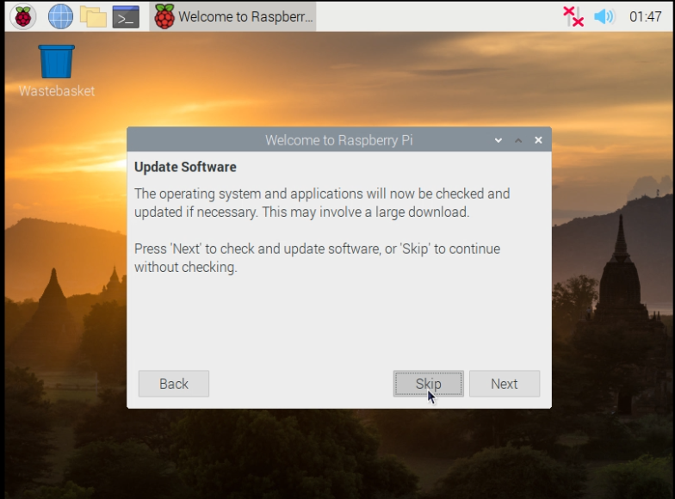

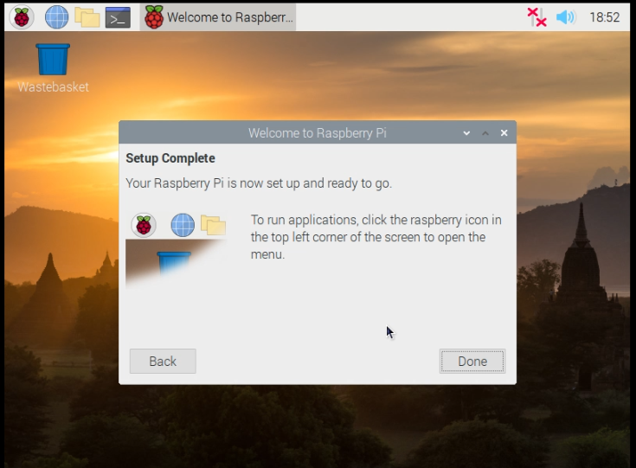**Step 15:** This is the last and the final process of yours installing the Raspbian O.S on your VMware box. Now you get the interface of Setup complete. Click on done button and Enjoy your Raspbian O.S on your VMware box.

**The final desktop of Raspbian O.S in the VMware workstation.**

